# Lambda Console overview

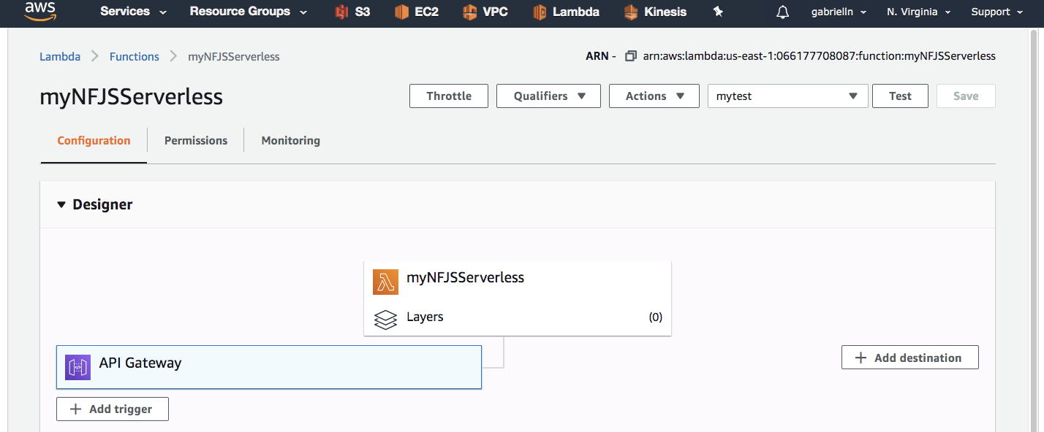

Trigger event

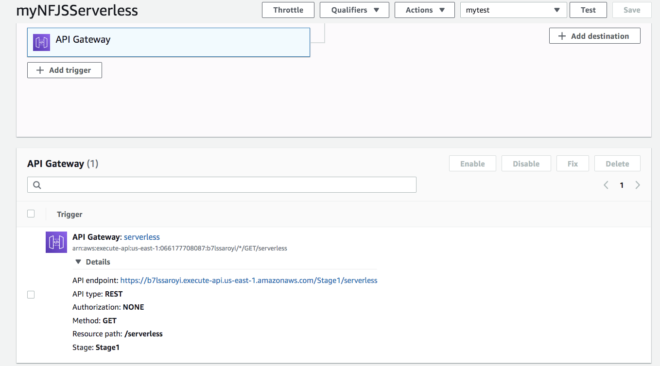

Adding more triggers

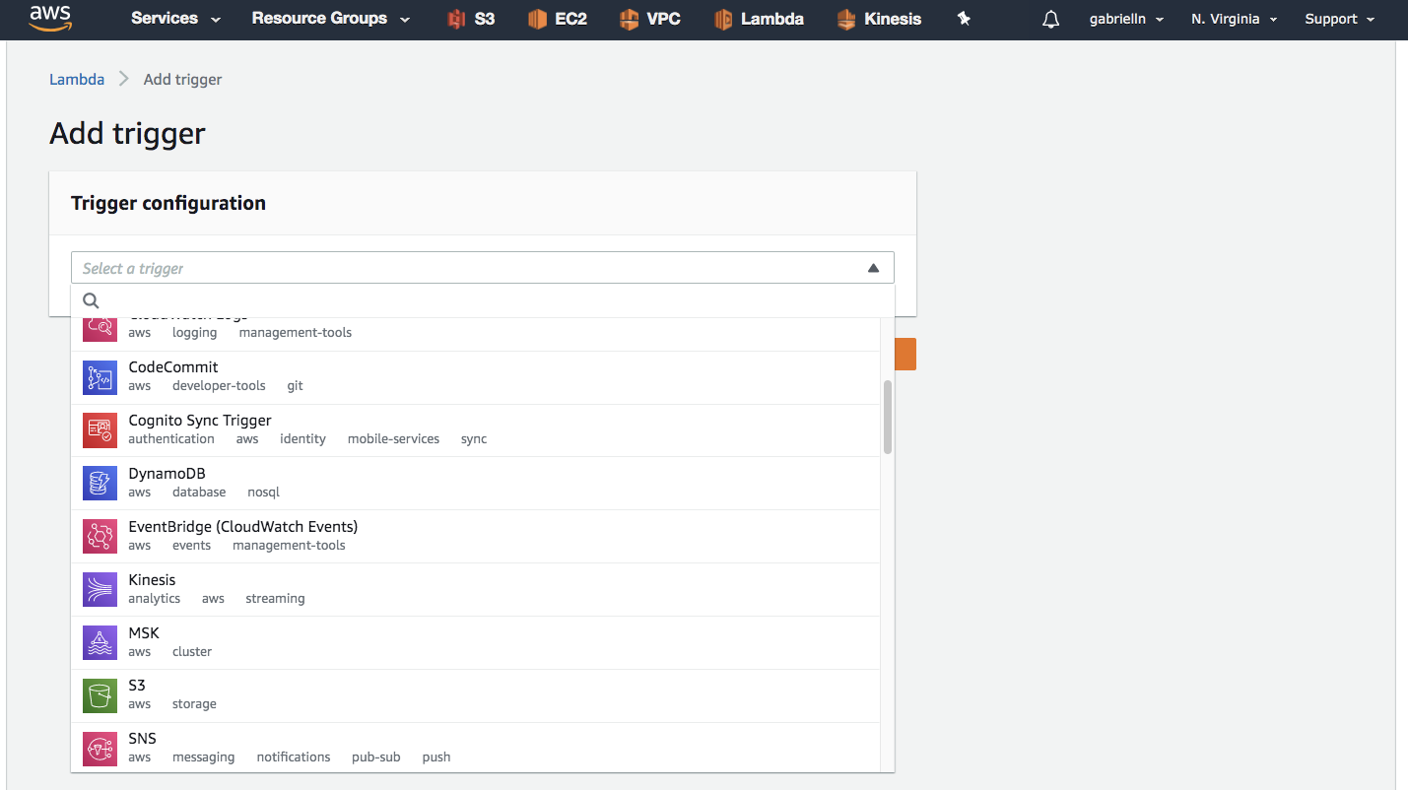

Function Code

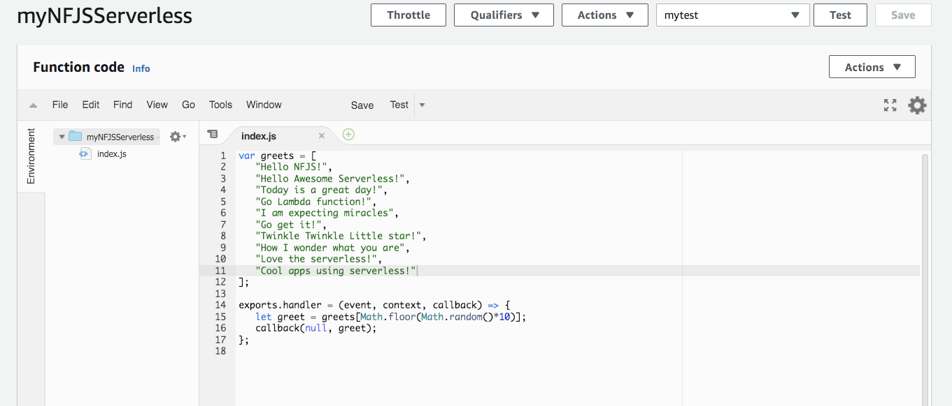

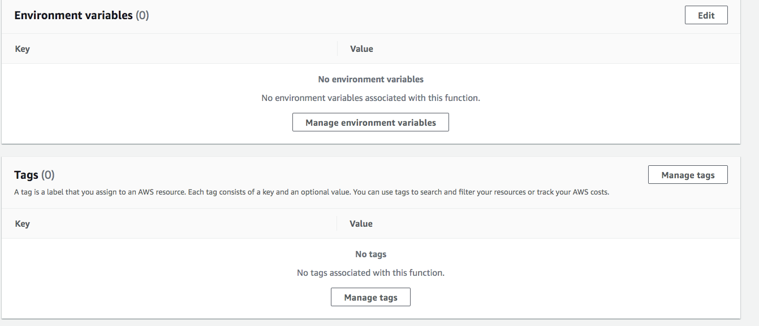

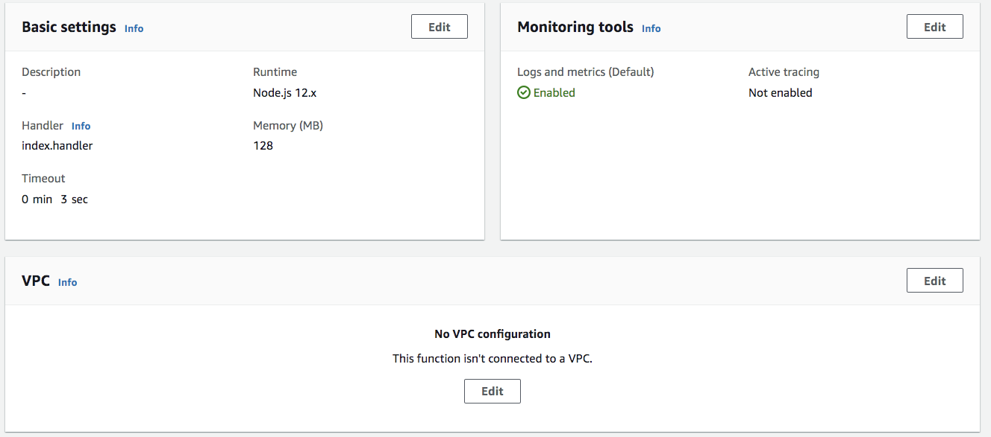

Basic settings

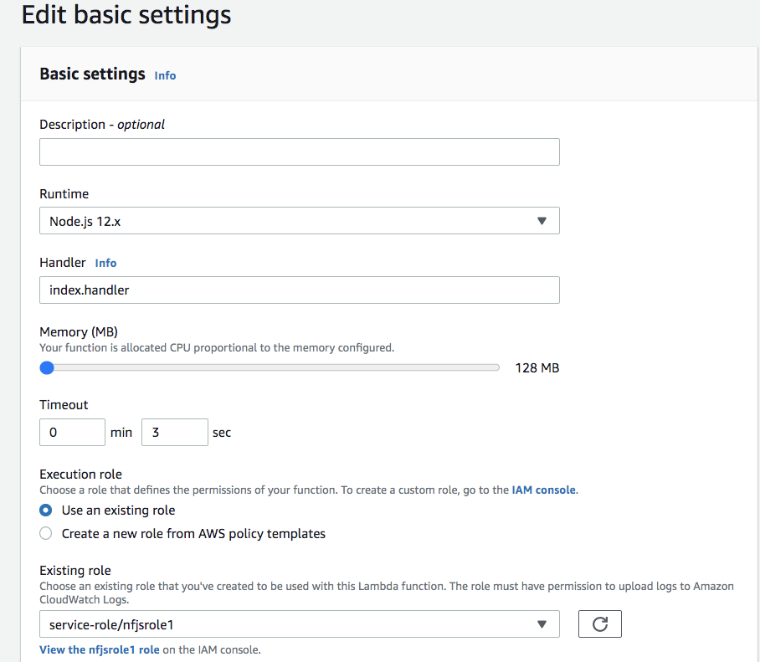

Edit monitoring tools

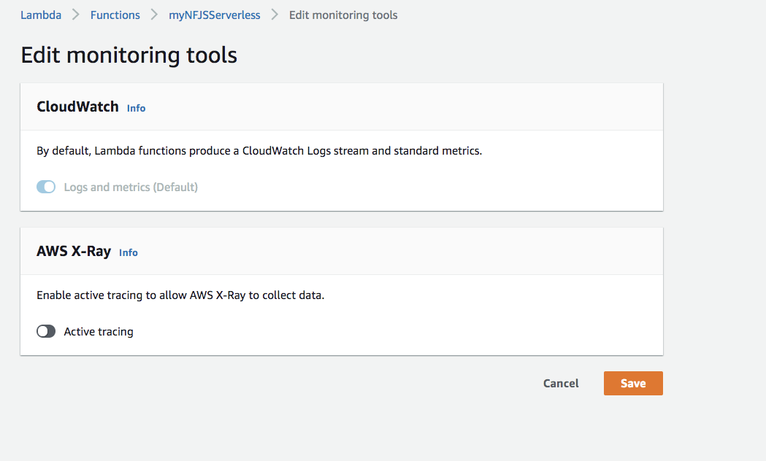

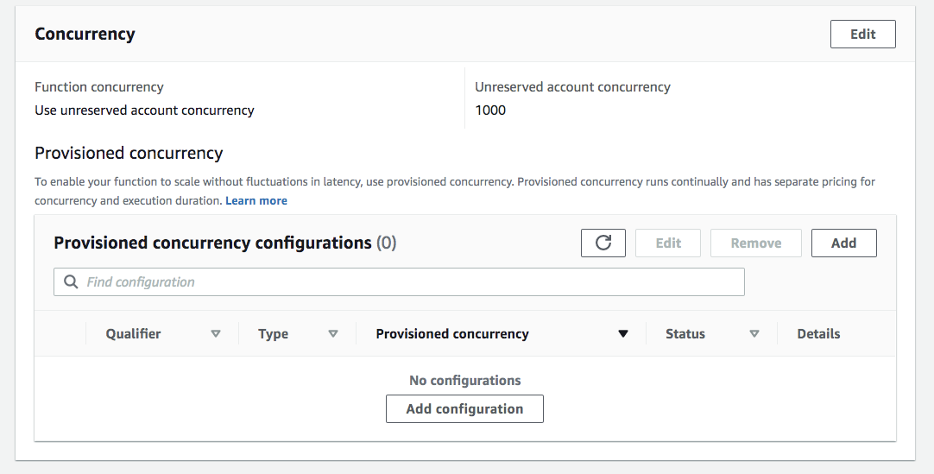

Async config

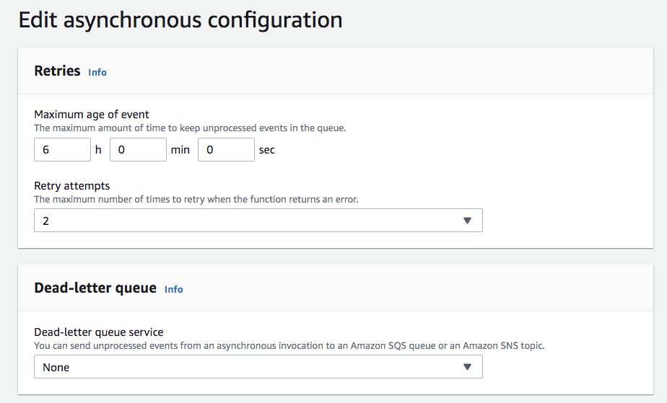

When you invoke your function asynchronously, AWS Lambda handles retries. Incoming events are placed in a queue before being sent to the function. If the function returns an error, Lambda retries up to two times. If the function is throttled, or Lambda returns an error, the event is kept in the queue for up to six hours. To change the default retry behavior, adjust the number of retry attempts and the maximum amount of time an item can be kept in the queue.

When an event fails all attempts or stays in the asynchronous invocation queue for too long, Lambda discards it. Configure a dead-letter queue to send discarded events to an Amazon SQS queue or Amazon SNS topic. Your function's execution role requires permission to write to the queue or topic.

Adding tests

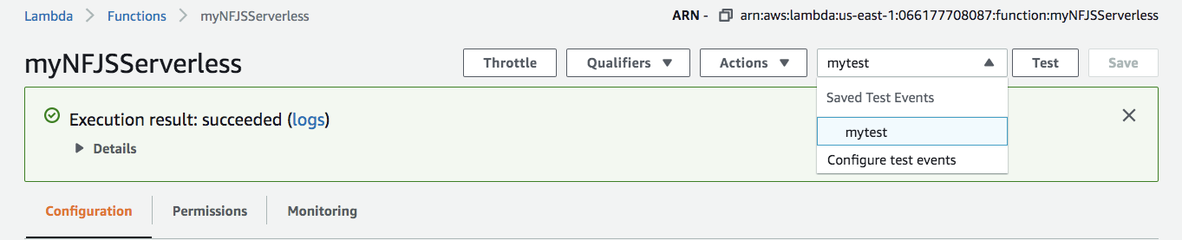

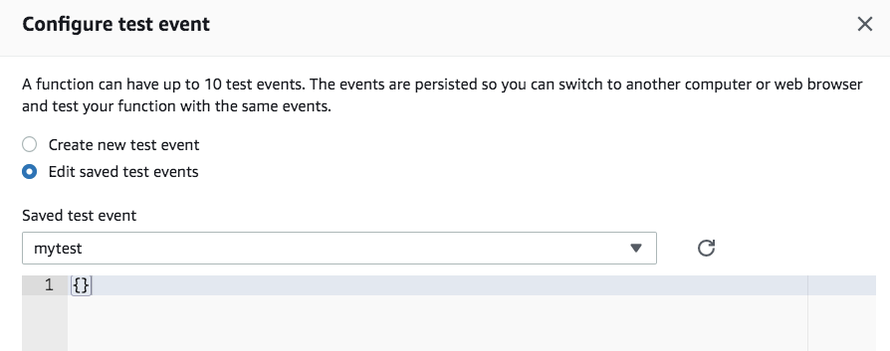

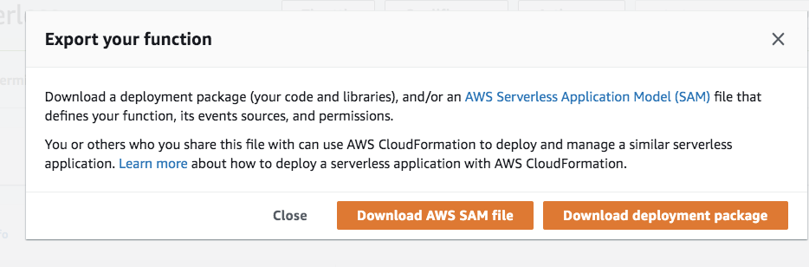

Permissions

